**LINIAR REGRESSION IN R**

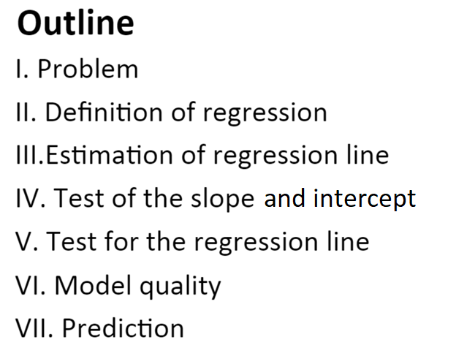

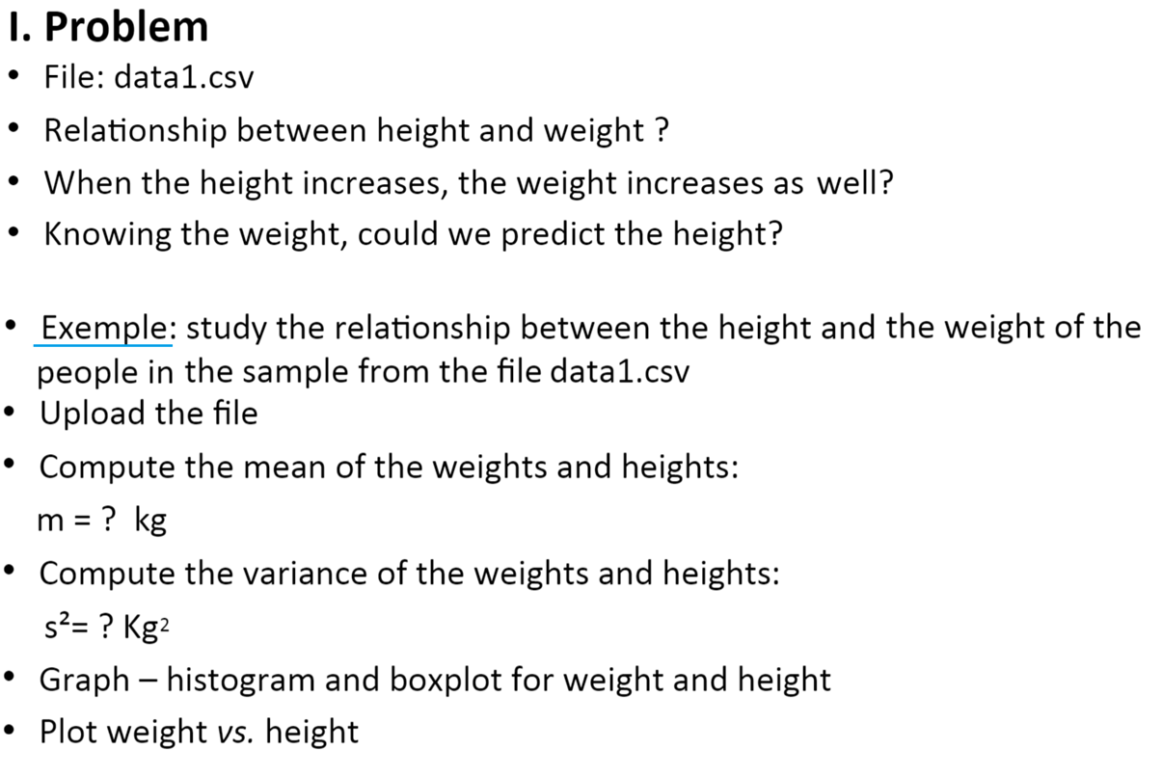

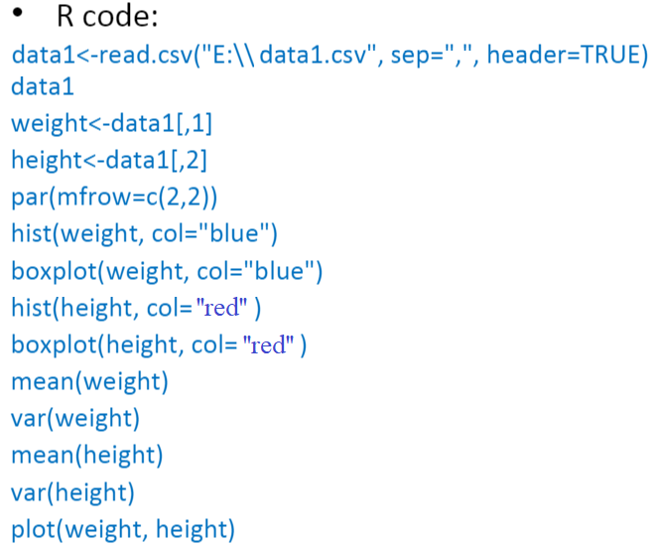

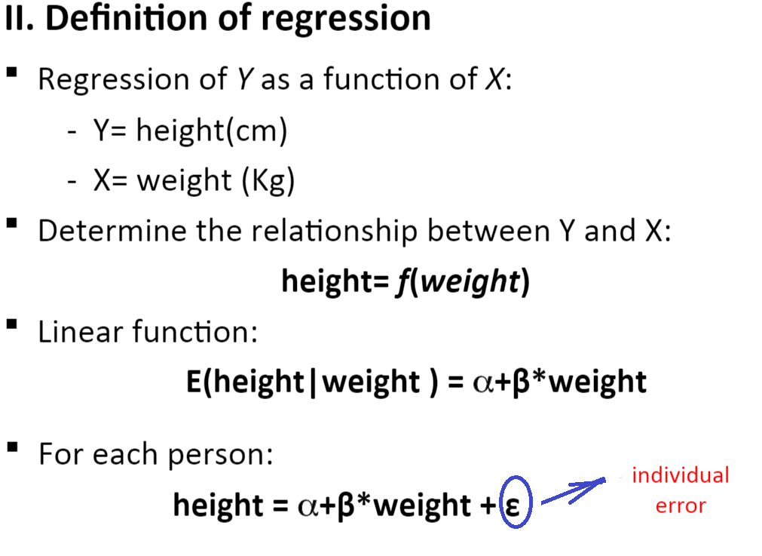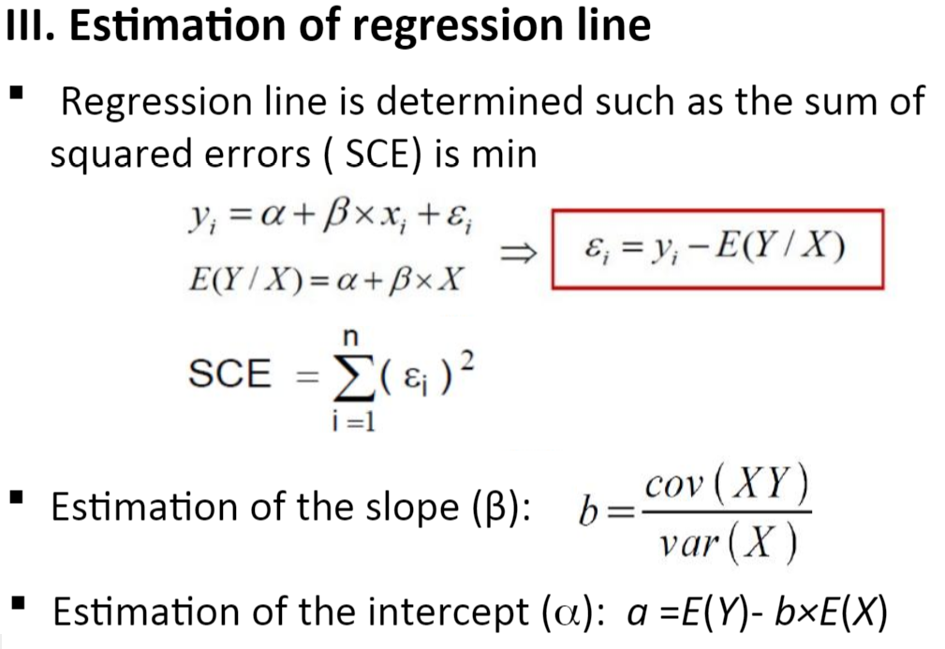

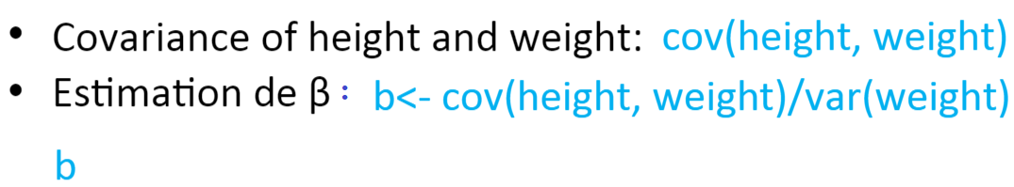

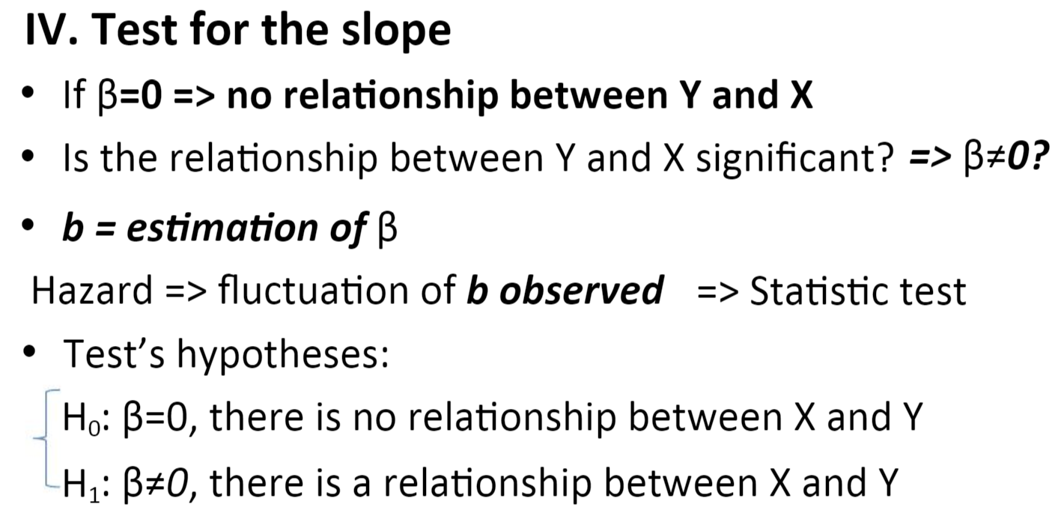

**Test for the intercept**

H0: *α* = 0; H1: *α*0 – t test

**Test for the model significance**

H1: *α* = β = 0

H1: *α* and β are not zero simultaneously

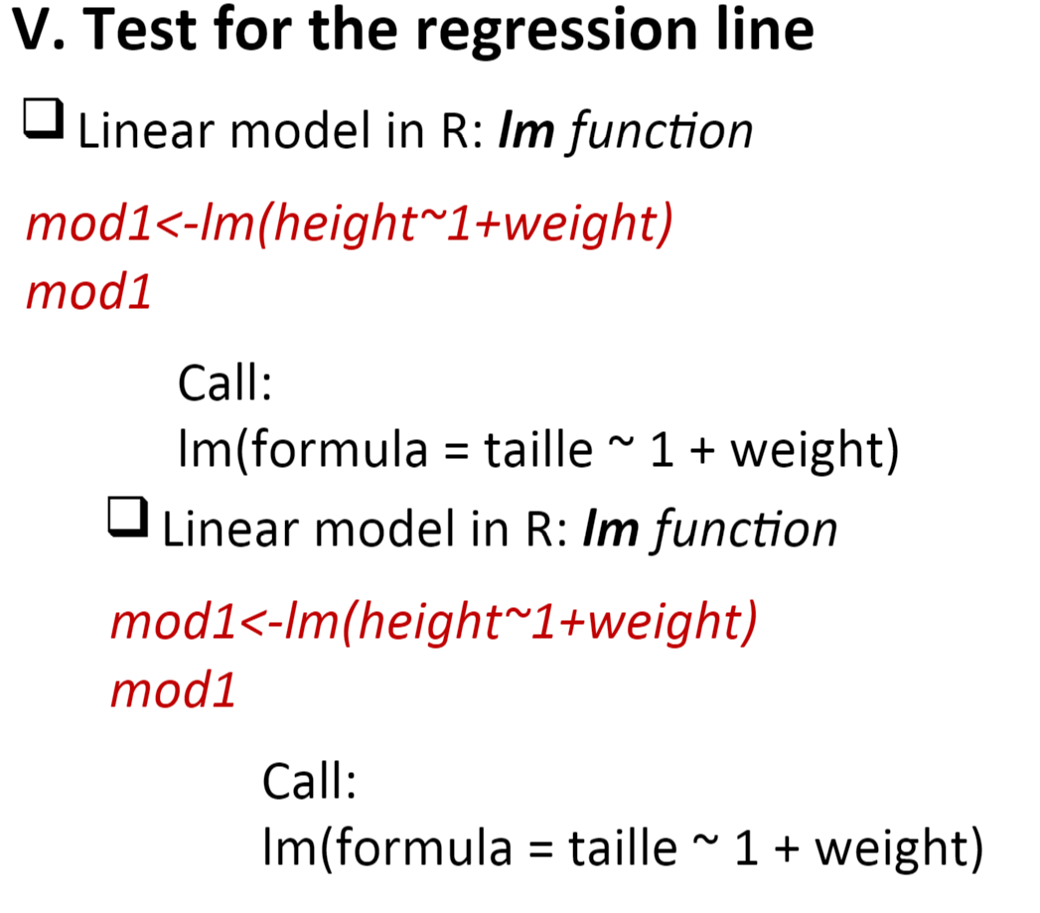

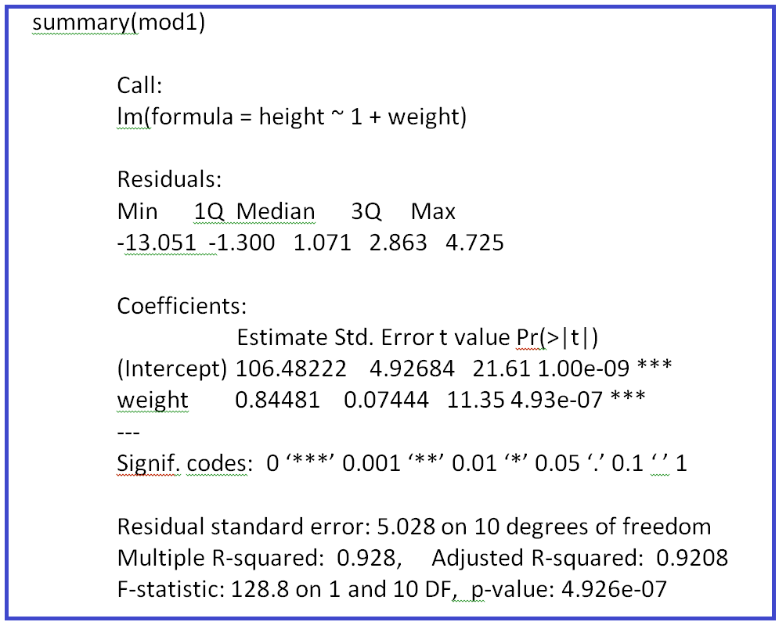

**VI. Model’s quality**

* *Confidence intervals for parameters*

*confint(mod1)*

2.5 % 97.5 %

(Intercept) 95.5045320 117.459904

weight 0.6789554 1.010671

* *Correlation coefficient*

*r = cor(weight, height)*

*r*

* *Determination coefficient*

*R2=var(mod1$fitted.value)/var(height*)

Remark: Retrieve the determination coefficient form summary(mod1)

**VI. Model’s quality**

The independent variable and the random variable must be uncorrelated

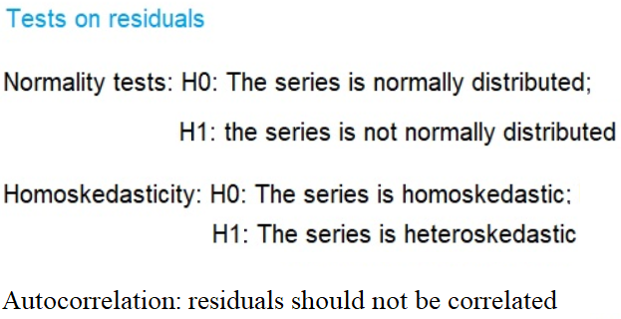

V. Test for the regression line

•

"## $%&!!

•

''#(#!

•

''(#!

•

"()*%(#!

•

plot(weight,height)

* *mod1$res # displays the residual in mod1*

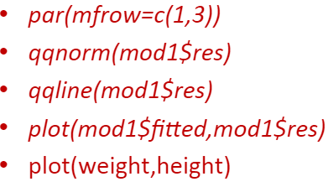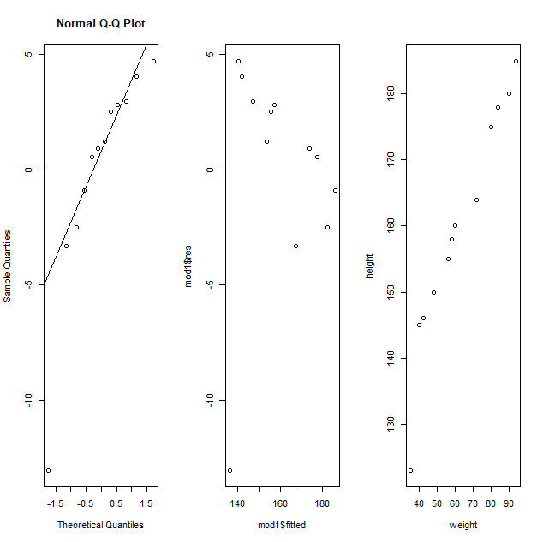

* *par(mfrow=c(2,2))*
* *plot(mod1)*

par(mfrow=c(2,2))

plot(mod1)

